Chad

## Population Data

The data set shows the political stability estimate of the country each year.

## # A tibble: 23 x 5  
## country iso3c date population popCategory5  
## <chr> <chr> <dbl> <dbl> <chr>   
## 1 Chad TCD 1996 7250975 small   
## 2 Chad TCD 1997 7503493 small   
## 3 Chad TCD 1998 7770048 small   
## 4 Chad TCD 1999 8053536 small   
## 5 Chad TCD 2000 8355654 small   
## 6 Chad TCD 2001 8678051 small   
## 7 Chad TCD 2002 9019233 small   
## 8 Chad TCD 2003 9373916 small   
## 9 Chad TCD 2004 9734767 small   
## 10 Chad TCD 2005 10096633 small   
## 11 Chad TCD 2006 10457124 small   
## 12 Chad TCD 2007 10818024 small   
## 13 Chad TCD 2008 11183588 small   
## 14 Chad TCD 2009 11560147 small   
## 15 Chad TCD 2010 11952136 small   
## 16 Chad TCD 2011 12360989 small   
## 17 Chad TCD 2012 12784750 small   
## 18 Chad TCD 2013 13220424 small   
## 19 Chad TCD 2014 13663559 small   
## 20 Chad TCD 2015 14110975 small   
## 21 Chad TCD 2016 14561666 small   
## 22 Chad TCD 2017 15016773 small   
## 23 Chad TCD 2018 15477751 small

# Population growth data

## # A tibble: 23 x 5  
## country iso3c date popGrowth popGrowthCat5   
## <chr> <chr> <dbl> <dbl> <chr>   
## 1 Chad TCD 1996 3.38 high growth rate  
## 2 Chad TCD 1997 3.42 high growth rate  
## 3 Chad TCD 1998 3.49 high growth rate  
## 4 Chad TCD 1999 3.58 high growth rate  
## 5 Chad TCD 2000 3.68 high growth rate  
## 6 Chad TCD 2001 3.79 high growth rate  
## 7 Chad TCD 2002 3.86 high growth rate  
## 8 Chad TCD 2003 3.86 high growth rate  
## 9 Chad TCD 2004 3.78 high growth rate  
## 10 Chad TCD 2005 3.65 high growth rate  
## 11 Chad TCD 2006 3.51 high growth rate  
## 12 Chad TCD 2007 3.39 high growth rate  
## 13 Chad TCD 2008 3.32 high growth rate  
## 14 Chad TCD 2009 3.31 high growth rate  
## 15 Chad TCD 2010 3.33 high growth rate  
## 16 Chad TCD 2011 3.36 high growth rate  
## 17 Chad TCD 2012 3.37 high growth rate  
## 18 Chad TCD 2013 3.35 high growth rate  
## 19 Chad TCD 2014 3.30 high growth rate  
## 20 Chad TCD 2015 3.22 high growth rate  
## 21 Chad TCD 2016 3.14 high growth rate  
## 22 Chad TCD 2017 3.08 high growth rate  
## 23 Chad TCD 2018 3.02 high growth rate

## Population trend

The plot shows the population trend of the country.

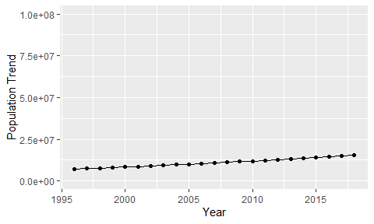

Political Stability Trend

# Population growth trend

The plot shows the population growth rate trend of the country.

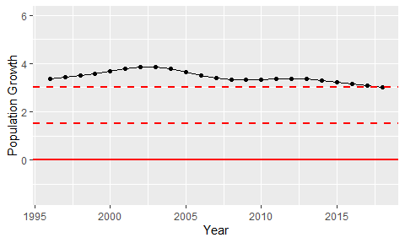

Population Growth Trend